

Thursday 4th Feb
6.45 for 7.30pm

Inn for all Seasons
Redruth
TR16 4AP

£10/ team must be booked in
advance
Closing date for entries
Tues 2nd Feb

Entries:
Download form from BHS website

Carvery £8.95 and
a la carte menu

.

 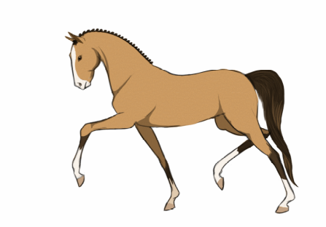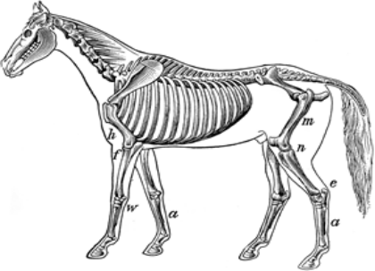Come early to order food if you want to eat. Feel free to ask committee members questions about what the BHS does for you in Cornwall.
Quiz starts at 7.30 prompt and we plan to finish by 10.00.
Entries: http://www.bhs.org.uk/enjoyriding/events-and-competitions/results?area=Cornwall

Don’t worry if you do not have a team we will find one for you to join.
More info, or to request emailed entry form: Tamsin.buzz@gmail.com 07899 991368

CORNWALL

